O.1.3 CARE Actions: Call For Proposals
Co-funded by the European Union (Ref: NDICI CHALLENGE/2023/448-254

ANNEX A - APPLICATION FORM

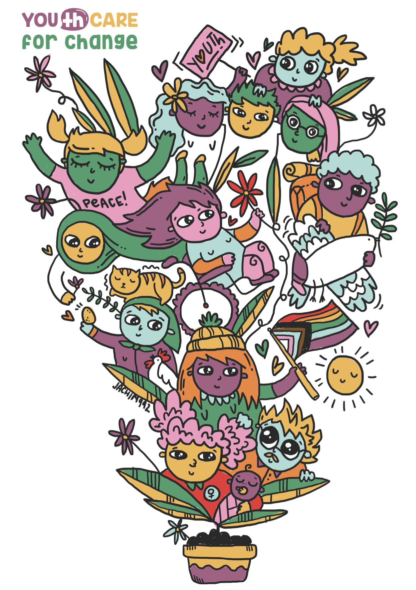

Table of Contents

- INSTRUCTIONS

- APPLICANT AND CO-APPLICANT GENERAL INFORMATION

- PROJECT DESCRIPTION

- INDICATIVE CALENDAR

- PROJECT APPLICANT’S DECLARATION

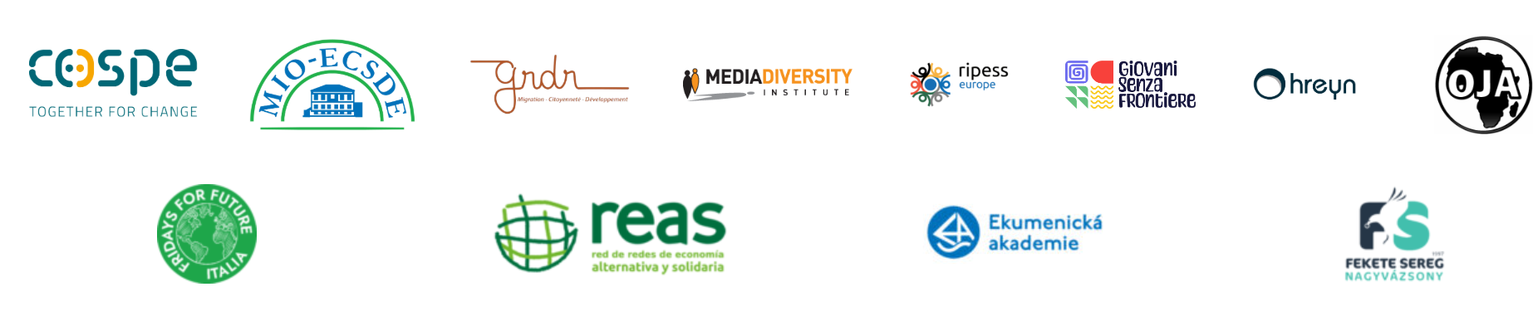

- INSTRUCTIONS
⚠️Important: Please do not use handwriting and make sure all information is clear and coherent to facilitate the evaluation process.
⚠️ Languages: Complete the Application Form + Budget (Annex A & B) in:
- For proposals under Lot1 International Networking: ENGLISH
- For proposals under Lot2 Making Space: English or National language. In the case you complete it in your national language it is obligatory to complete the “Summary” in the Project Description (Part 3 of Application form) and the “Budget form” (Annex B) in English
📤 How to Submit: Upload the documents by following the instructions in the Call for Proposals.
❌ Missing information will result in exclusion from the call, so double-check before submitting!

Deadline to submit your application: February 28th 2026 - 11:59 pm CET Local Time

Title of the project

Country/ies of intervention

Name of the Applicant

Name of Co-applicant(s)

Project duration (in months)

Lot 1: Networking (international) or Lot 2 Making space (national)
Total budget requested | _{<IN EUR>}
Target group

2. APPLICANT AND CO-APPLICANT GENERAL INFORMATION
Please, note that the main applicant organization must have legal form (be formally registered, and a bank account in order to demonstrate administrative and financial capacity to manage a sub-grant.

APPLICANT

Name of applicant in its national language
Name of applicant in English
Address (if any)
Type of organisation
Web site (if any)
No. of registration (if available)
Date of registration /recognition (if available)
Contact person:
Name:
Phone number:
Email address:

- Provide a brief background about the applicant organization, underlying previous similar experiences, mission and vision of the organization (max. 1500 characters)

- Can you briefly describe your previous similar experiences similar to the proposed action? Please indicate objectives, duration, budget size, funding actors. (max. 1500 characters)

- What is your experience so far with the YOU(th) CARE Project, if any? E.g. you follow on social, have participated in events/activities (& which), you are registered in the platform, etc.

CO-APPLICANT (S) - In case of more than one Co-applicants, please add the needed table/information

Name of applicant in its national language
Name of applicant in English
Address (if any)
Type of organisation
Web site (if any)
No. of registration (if any)
Date of registration /recognition (if available)
Contact person:
Name:
Phone number:
Email address:

- Provide a brief background about the co-applicant(s) organization, underlying previous experiences, mission, and vision of the organization (max. 1500 characters)

3. PROJECT DESCRIPTION:

Provide a SUMMARY of the project including all the following information (max. 5000 characters):

- Explain the objective(s) of the proposal;
- Define and describe the target group of the project, their needs and problems, and indicate how the proposal will address these needs;
- Briefly describe the type of activities proposed;
- Explain the project idea detailing short, medium and long term expected changes;
- Outline the general timing of the implementation of the proposal
- Explain how your project will be in line with the CARE and Intersectional Approach
- Explain why your project should be funded!

Objective(s) of the action (max 1.500 characters):

Describe the main activities of the project (max 8.000 characters):
What activities will be needed to produce the products, goods and services that will contribute to achieving medium-term changes?

- Coherence, efficiency, quality, and impact of the action with reference to the YOU(th) CARE Agendas’ priorities (max 1.500 characters):
How is my project's idea aligned with the priorities indicated in the YOU(th) CARE Agenda of the country/ies where the project will be implemented?

- Project context analysis (max. 1500 characters):
How is the situation in the country/ies related to the area of intervention of my project idea? What are the problems young generations are facing? What are the main stakeholders that can influence those problems?

The CARE and Intersectional Approach (max. 3000 characters)

Does my project pay attention to the multidimensional aspects of CARE and gender equality? Please, describe how your project will apply the CARE and Intersectional Approach in their activities

Remember that applying a participatory and gender approach is one of the key criteria needed to win the call!

Has my project possible connections with other projects previously sub-granted actions by the YOU(th) CARE or new ones, under this call in the territories/countries participating ? (please, name here the other projects or youth groups submitting other proposals with potential links and complementarities, if any)

- Sustainability of the action (max. 1500 characters):
How the positive effects that the project will have on the territory will remain after its life-span? Please, think about possible changes at the social, cultural, economic, and environmental level the project could bring on your territory and context.

- Impact and outputs? (max. 1500 characters):
Could you please describe how your proposal will bring changes in the context where you will take the action? Could you also list at least 3 outputs/deliverables that the action will produce?

4. INDICATIVE CALENDAR
Please, remember that sub-granted projects must have a duration
Between 8 to 10 months for projects under Lot1. International Networking
Between 6 to 8 months for projects under Lot2. Making Space

Activities / Months | 1* | 2 | 3 | 4 | 5 | 6 | 7 | 8 | 9 | 10
Activity 1
Activity 2
Activity 3
etc.
Add as many activities as your project ideas foresee. Remember to specify each type of activity. If your project doesn't have a duration of more than twelve months, just leave the other cells blank.* Please change the number with the actual month of implementation (i.e. SEP-25)

5.PROJECT APPLICANT’S DECLARATION

1*. I hereby declare that both the project applicant and the co-applicant are established in one of the eligible countries under this call for proposals
2.* I hereby declare that the project applicant is formally registered in the country where it was established and owned a bank account in the same country
3*. I hereby declare that both the project applicant and the co-applicant are non-profit-making and non-governmental bodies
4*. I hereby declare that both the project applicant and the co-applicant can be considered as Youth-led initiatives and/or Youth-focused initiatives**
5*. I hereby declare that both the project applicant and the co-applicant are neither a beneficiary of a grant (neither lead, nor co-applicant, or affiliated entity) nor associates or contractors in the frame of EuropeAid/173998/DH/ACT/Multi call for proposal AND not have the financial, administrative or operational capacity to compete directly for EU funding under the EuropeAid/173998/DH/ACT/Multi

* This condition is compulsory to participate to this call for proposals
** Youth-led initiatives are generally understood to be organizations having the majority of the board formed by youth (below 30) and/or having the majority of the staff formed by youth (below 30). Youth-focus initiatives are generally understood to be initiatives having the support of youth engagement as mission and/or promoting activities focused mainly on youth engagement.

Note for the applicants: The documentary evidence (legal registration and financial statements) should not be submitted within the deadline for submitting proposals. In case your proposal will be selected, the evaluation committee will request to provide it.

____________________________________
Signature and stamp of the Project
Applicant’s Legal representative

‘Target groups’ are the groups/entities who will directly benefit from the subgrant
Such as CSOs/NGOs, association, formal Educational Institutions, Educational communities, cultural institution, Youth Networks, collective
Such as formal and non formal CSOs/NGOs, association, Educational Institutions, Educational communities, cultural institution, Youth Networks, collective, movements

