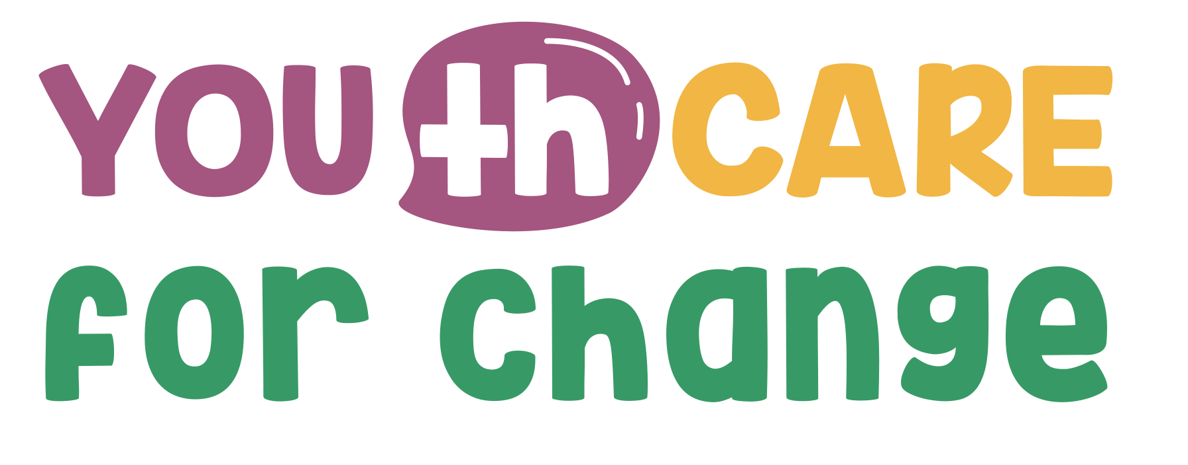

Frequently Asked Questions 2nd Call of Proposals

General Eligibility
Can we submit a project that doesn't fully align with the participating country(ies)s priorities as presented in the CARE Agendas? Yes. However, proposals that align closely with CARE Agendas may be more competitive.
Is there a maximum age for project team members? No. There is no age limit for team members, but youth participation and leadership are essential.
What is your definition of "youth"? Generally, youth refers to individuals aged 18–30. Refer to the Call guidelines for youth-led and youth-focus initiatives definition.
Can underage adolescents (under 18) participate in the activities? Yes, with proper safeguarding measures.
Is it okay if our organization is a social cooperative? Yes, if it meets all eligibility criteria.
If we are not youth-led but youth-focused, are we eligible? Both Youth-led and Youth-focus initiatives can apply, assuming that they meet all the eligibility criteria mentioned in the guidelines. In the reference note of the guidelines, you can also find the definition:
Youth-led initiatives are generally understood to be organizations having the majority of the board formed by youth (below 30) and/or having the majority of the staff formed by youth (below 30). Youth-focus initiatives are generally understood to be initiatives having the support of youth engagement as mission and/or promoting activities focused mainly on youth engagement.
Can we submit more than one proposal? No. Just ONE proposal ONE LOT.
Can we submit to both Lots in the one as lead applicant and in the other as a co-applicant? No, you can apply in one Lot either as lead applicant OR co-applicant.
Can we submit a proposal if we have been granted in the YOU(th) CARE 1st Call of Proposals (as Applicant or Co-Applicant)? No, the Youth Initiatives already beneficiary of a sub-grant under this project will not be eligible for a second grant.Refer to the Call guidelines
Must we have a co-applicant? Yes, it is mandatory. Refer to the call guidelines.
Is the call compatible with ERASMUS+ funding? Yes, if there is no overlap in funding for the same activities. The project is not compatible to EuropeAid/173998/DH/ACT/Multi.

Partnerships
Can we partner with an organization that didn’t participate so far in the YOU(th) CARE process? Yes, as long as it is eligible.
Can informal youth groups be co-applicants or led-applicants? Only co-applicants. In order to be lead-applicant, they must meet eligibility criteria (e.g., legal status).
How do informal groups prove they actually exist? Informal groups and networks can provide a proof of their activity and stability, e.g.a website or social media accounts as well as describe their activity (existence) in the related part of the Application form (previous experiences)
Can project partners be from different or same countries? It depends on the Lot:
Lot 1: BEYOND BORDERS-INTERNATIONAL NETWORKING: Partners should be from different countries (at least two different countries in the partnership).
Lot 2: MAKING SPACE! Partners should be from the same country.
How many partners can we involve? There’s no fixed limit. Partnerships should be well-justified and manageable. We highly recommend not to create very large partnerships.

Project Scope & Activities
On Lot 1 – International Networking, are applicant associations required to work on a specific thematic area? No, the scope is to proposals covering various topics as long as they are somehow linked to the CARE Agendas priorities (Refer to the Call)
Do activities have to take place in the applicants’ country/ies? Yes.
Does the project need to involve multiple countries? It depends on the Lot. See above.
Can we integrate our project into an existing national project? Yes, if it's not already funded by a DEAR grant.
Can our project target migrant communities (e.g., Arabs or Ukrainians in Belgium)? Yes, of course. When we talk about countries, we do not refer to nationality. Everyone living in these countries is a target for the projects and can apply to the sub-grant.
Can we involve high school teachers and students? Yes, as target groups of the project, but the applicants should be youth-led and youth-focus organizations.
Can the project be aimed at our own members rather than the public? Yes, but broader impact is encouraged.
Is there a minimum or maximum number of participants per activity? No. Numbers should be realistic and proportionate.
What if our project covers more than one LOT? You need to select one LOT as your main focus and justify any overlap.
How can we capitalize on previous projects since the same organisations cannot be applicants nor co-applicants again if granted before? The applicant to this 2nd call can be stakeholders of the previous project (not awarded with budget) and from the larger community involved. Also, new actions could build on actions implemented in the previous project call.

Application Process
Can we complete the Application form in our national language? Please refer to the Instructions in the Application Form that clearly states:
● For proposals under Lot1 International Networking: You should complete the Application Form and the Budget in ENGLISH.
● For proposals under Lot2 Making Space: English OR National language. In the case you complete it in your national language it is obligatory to complete the “Summary” in the Project Description (Part 3 of Application form) and the “Budget form” (Annex B) in ENGLISH.
Can we download a blank proposal form? Yes. A printable version is available. But handwritten annexes are not allowed.
Can we save our proposal and finish it later? Yes. You may draft and complete it before submitting. Once you have uploaded the proposal you will not be able to change it.
Do I need to fill in the employees' names in advance? No, this is not necessary for the submission of your proposal.

Budget & Human Resources
What type of contracts can we use for human resources? Contracts should respect the national legislation of the country of implementation. They may be task-based or hourly. Freelancers can be included if legally authorized.
Is there a minimum or maximum number of human resources allowed? No. However, human resources should reflect the realistic scope and budget of the project. You need to keep a good balance considering the project’s duration and the costs of the rest of the activities. The balance of the budget will be evaluated (see also the Evaluation Grid).
Is voluntary work accepted within the project? Yes.

Thematic Priorities
Are we limited to three topics as indicated in the CARE Agendas? No. You may address additional topics. This can enhance your score but isn’t mandatory.
Can we include topics outside the CARE Agendas priorities? Yes, but alignment with national priorities may improve the chances of selection.

➡️ If your question isn’t covered here, please refer to the official call document and/or contact the country focal point directly.

